Mobile Pantry Leadership guide
Steps to prep for Mobile pantry two days before the event:
- Look at sign up genius list (Deana gave you the list on the clipboard in the bag) to create volunteer email. (I usually send it to myself and add all the volunteers under BCC)
- Send email to volunteers:
Hello Mobile Pantry Volunteers!
Thank you for your interest in this volunteering with the Mobile Pantry on Wednesday, April 13th – in just a couple days. Your assistance makes this effort possible. Please feel free to call or email me regarding any questions you may have. I am attaching some information that will hopefully answer most questions folks may have. If you have volunteered before, much of this information may be a repeat with a few changes from last semester.
I look forward to seeing you on Wednesday. Because the Mobile pantry is outside, please dress for the weather. Thank you!
(Sign your name so they know you are the substitute Mobile “Manager”)
- Attach Updated Volunteer Instructions
Steps to prep for Mobile pantry the day before the event:
- When the RSVP list is available, email Kelly Brown at Diaper Bank of the Ozarks kelly.b@dbozarks.org to let her know about the total numbers for each size of diapers requested (on RSVP list).
- Connect with Tim Smith at Crosslines (his emails are funky, I either text or call instead; he prefers this) on his cell (417)551-2176 to confirm arrival of the Mobile truck the next day and time. He will tell you the volunteers who will be there. I usually make note so I will remember what to call them (other than “hey, you, Mr. Mobile guy” )
- Once I get the list of food items, I make a list on four nametag stickers (in the bag) to stick on the tables for the volunteers to see. Sometimes the food list changes at the last moment, so this step is also included in step 5.
- Create check-in sheet from RSVP list. I create headings and page breaks and print 4 copies (one for me, one for drive through greeter, and two for walk up greeters).
  - To make changes to the form in Excel, I go to the Page layout tab, click on “Breaks” under Page Setup, and check the print Gridlines and Heading boxes under the Sheet options.
  - Just below each page break, I add a row where I put the headings (that way there is a heading on each page for the volunteers to see what information they need to collect)
  - I create these headings and shift the columns to make room for all the words.
# of FAMILIES in house | # 60 + | #19-59 | # 18 and under | Other info
  - I add the headings to the added row at the top of each page.
  - Print preview: Landscape Orientation, Narrow Margins, Print One Sided. Each page will look like this:
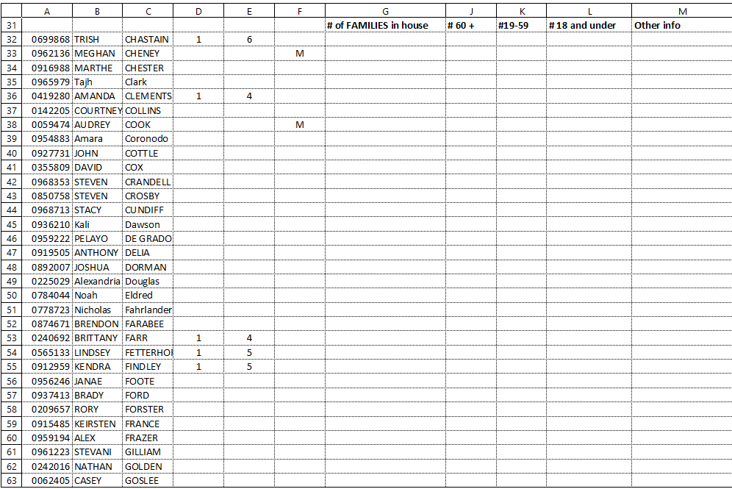
  - Print one side only, 4 copies of each packet
  - Send copy to Deana (I keep this info in my documents)
  - Staple on upper right so when volunteers flip pages, they are not hampered by the left side staple.
  - Put sign-in sheet packet on clipboards.
- Day of event:
  - Arrive: (Wednesdays I arrive at 11:00. Volunteers arrive at 11:30 and Students arrive at noon until 2.) Often times the truck arrives early and they sometimes start to set up and then you have to move things. Also, some volunteers arrive early and then are confused about where to be.
  - Wear your name tag so volunteers know who you are.
  - Set up:
    - Find out from Crosslines volunteers what food will be available. It is helpful to have this info on a sticker stuck to the tables so all volunteers know what food to bag and give out.
    - Follow the set-up map on your clipboard. Two to three tables at drive up, 5-4 tables for walk ups.
    - Diapers should be next to the greeter for the walk-up station. The Greeters should be the only person to get diapers. Student should not be able to get them themselves. It is helpful to organize these by size so they are easier to identify by the Greeters.
  - Greet:
    - Greet your volunteers and check on your sign up list of what role they signed up for (greeter, bagger, set up) I have a new role of re-stocker. This should be one of the baggers who gets food items from the truck and puts it at the bagger station. This person should be able to walk and carry heavy items. Because I did not start with this role when I created the sign-up list, I have to ask volunteers if they would be willing to fill that role.
    - Pay attention to the times new volunteers will be coming and what time volunteers need to leave. Sometimes it is important to ask folks to shift roles if not everyone shows up.
  - Supervise:
    - Travel between the stations and see what is needed. If there are volunteers who are not busy and there is need someplace else, you can move them. If they need your help, you can pitch in for a while.
  - Closure:
    - Around 1:30, you may check to see what quantities of food are left. (sometimes we run out of eggs, or such at one station, but the other has a lot.) You can move things as necessary.
    - Close to the end, you may want to start removing tables when they are not used.
    - Please let volunteers know they may take food if it is left at the end.
    - If you have time, energy and ability, you can take some food to the Tech Ed food pantry. If not, no worries. I usually only have time and energy to take a couple boxes and possibly some things that may fit into the bags we bring.
    - Pick up trash (pieces of box, plastic sacks, etc) from the pantry, and look around to make sure Crosslines has all their things.
    - Breathe and relax for a job well-done!!!

