



**International Student Welcome Guide**

Table of Contents

**WELCOME …………………………………………………………………………………………………………………… 3**

**Special Concerns for International Students**

**After your Arrival …………………………………………….…………………………………………………………… 4**

**Medical Insurance ………………………………………………………………………………………………………… 5**

**F-1 | Maintaining Legal Status ……………………………………………………………………………………….. 5**

**Transfer ……………………………………………………………………………………………………………………….. 6**

**Transportation & Traveling ………………………………………………………………………………………...… 7**

**Employment ………………………………………………………………………………………………………...………. 8**

**Academic Advising**

**What is an Academic Advisor? ………………………………………………………………………….…………. 11**

**Assigned Advisor ………………………………………………………………………………………………………... 11**

**E-advisor ………………………………………………………………………………………………………………….… 11**

**Financial Information**

**Paying Tuition at OTC ……………………………………………………………………………………………….… 12**

**MyPay MyWay ……………………………………………………………………………………………………………. 12**

**OTC SmartCard …………………………………………………………………………………………………………... 13**

**Campus Resources**

Services & Offices ……………………………………………………………………………………………………….. 14

**Living in Springfield**

Finding a Place to Live ……………………………………………………………………………………………….... 17

Banking ……………………………………………………………………………………………………………………… 17

Cell Phones ……………………………………………………………………………………………………………….... 18

Shopping ………………………………………………………………………………………………………………….… 18

Parks & Recreation …………………………………………………………………………………………………...… 19

Shipping & Postal Services ………………………………………………………………………………………….. 19

Emergencies & Safety ………………………………………………………………………………………………..... 19

Weather ……………………………………………………………………………………………………………………... 19

Hospitals ……………………………………………………………………………………………………………………. 21

**Campus Maps** ……………………………………………………………………………………………………………. 22

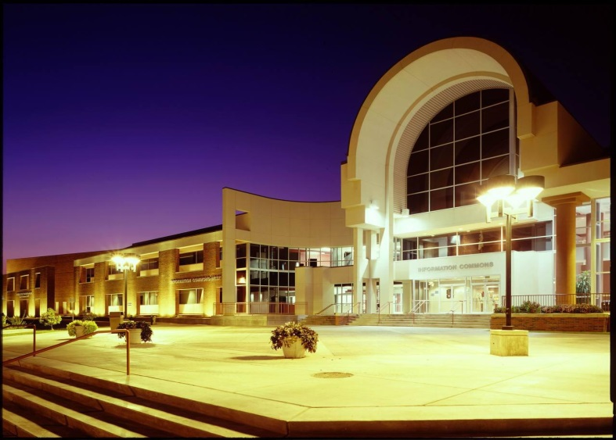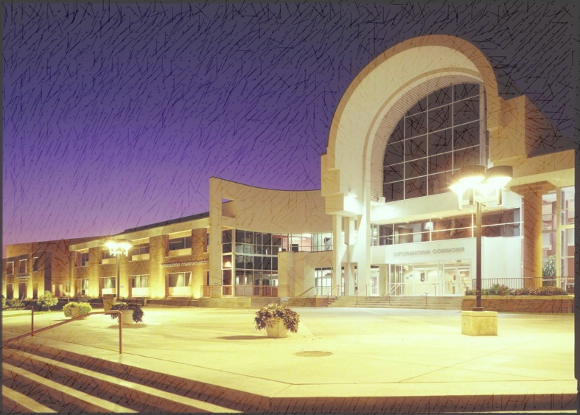

**WELCOME TO OTC**

About Ozarks Technical Community College

Ozarks Technical Community College (OTC) was founded on April 3, 1990.

MISSION STATEMENT

*The college mission is to provide accessible, high quality and affordable learning opportunities that transform lives and strengthen the communities we serve.*

VISION STATEMENT

*The college vision is to serve our communities by expanding opportunities for personal and professional growth through our commitment to excellence and innovation.*

CORE VALUES

*Quality – Inclusion – Integrity – Opportunity – Accessibility – Learning – Innovation Collaboration – Respect – Affordability – Personal Growth – Professional Growth*

Special Concerns for International Students

After your Arrival

**International Orientation**

The Acceptance Letter that you receive with your I-20 form from the College, will include details about when and where the mandatory International Student Orientation will be held. Typically, it will be held the week before classes actually start, following the Academic Advising seminar referred to as STAR (Student Advising and Registration seminar). For the orientation, you will need to bring the following documents:

* Passport
* Visa
* I-20
* Immunization Records
* Proof of Medical Insurance (if applicable)

*If you did not bring these documents during the International Orientation, you will need to bring them to the IPO within the first week of classes.*

In addition, you will need to complete a student information update form. You will be asked to provide the name and phone number of someone whom the IPO may notify in case of an emergency. This contact can be someone from your home country or the United States. You will also need to provide your U.S. address and contact information.

***Academic Advising***

You are required to meet with the International Student Academic Advisor prior to registering for classes.

To help determine your skill level and requirements before enrollment, one of the criteria below must be met:

* Transferring ELI students who earn less than 80 percent in either the Writing Grammar Final Exit Exam Essay or the writing class itself should be placed in ENG 050 or ENG 099 paired with ENG-101.
* Students with an IELTS score of 5 in writing, or a TOEFL score of 15-16 in writing should be placed in ENG 050 or ENG 099 paired with 101.
* Students who have a 5.5 or 6 in IELTS (writing) or a TOEFL score of 17-23 (writing) can be placed in ENG 101 directly.
* Transfer F-1 students with 15 credit hours or more completed, can register for ENG 101 if they desire.

*Medical Insurance*

Medical insurance is mandatory for all international students attending OTC. You may use the pre-approved insurance plan available for OTC international students. All F-1 students will need to pay in advance for the first semester of coverage before an I-20 is issued. In following semesters, before you will be allowed to register for classes you must provide the IPO with proof of coverage through the end that semester.

To obtain a medical insurance waiver, you must present a proper proof of insurance. Your medical insurance must have a medical evacuation & repatriation plan. If your insurance does not offer this coverage, you may purchase a supplemental plan using the pre-approved insurance supplement plan.

***Tuberculosis (TB) Tests & Immunization Records***

In compliance with directions of the World Health Organization (WHO) and the United States Centers for Disease Control (CDC), Ozarks Technical Community College requires tuberculosis screening for all F-1 students. Tuberculosis (TB) test must be done within the U.S. If you have not been tested in the U.S., you will need to be tested and submit the result to the IPO within 30 days of your program start date. Testing is available through the [Jordan Valley Community Health Center](https://local.demandforce.com/b/jordanvalleycommunityhealthcenterspringfieldkingsley/schedule) and [CVS Pharmacy’s Minute Clinic](https://www.cvs.com/minuteclinic/services/tb-testing)

F-1| Maintaining Legal Status

There are basic requirements for maintaining F-1 status in the United States. It is very important that you understand what you are permitted to do under the conditions of your status, especially in terms of enrollment and employment. Violating the terms of your status can cause severe consequences up to and including deportation. Follow the guidelines below to ensure that you remain in good standing with Immigration Services (USCIS).

* Keep your passport valid at all times.
* Enroll and complete a full course of study each fall and spring semester (12 credit hours). Only 3 hours of online courses count towards your full-time enrollment requirement.
* Report changes of address, phone number, and change of degree/or program of study to the IPO within 10 days.
* Report changes of name in passport to the IPO within 10 days.
* Maintain good academic standing (2.0 grade point average).
* Attend the school noted on your I-20.
* Studies should be completed by the completion of studies date on the I-20. However, if more time is needed, a program extension may be obtained from the IPO before the completion date has passed. Documents cannot be extended after they expire.
* DO NOT engage in any unauthorized employment.
* Inform the IPO office if planning to transfer to another school at same or different program level.
* Have an IPO officer sign your I-20 before traveling outside the U.S. if you plan to return to continue your studies.

***Reduced Course Load***

Under certain conditions F-1 students may be allowed to enroll less than full time. However, these conditions are limited and you will need to request permission from the IPO. Never enroll in less than full time course load without first consulting with the IPO.

Transfer

If you are transferring to another school in the U.S. as an F-1 student, you must first ensure your admittance at a new school and turn in the "Transfer Out Request" form before the IPO "releases" your record in SEVIS. This transfer release means that your information will be accessible by a new school so that they can issue a new I-20 using the same SEVIS ID. Please remember that once we release your data, we will not be able to reverse it and only one school can access your information once released. This means that you will need to think carefully about choosing a new school.

Speak with the International Student Advisor at your new institution to learn what information and forms may be required from OTC. Then, make sure to inform the IPO at OTC that you are transferring to another institution. As soon as you arrive on your new campus, report to the International Student Advisor. He/she will make sure that your transfer process has been completed according to immigration regulations. If you wish to leave the U.S. during the transfer, consult your International Student Advisor.

***Transfer Options***

International students wishing to transfer into a Bachelor's degree program are not limited with regard to where they can apply after completing their studies at OTC. Articulation agreements between OTC and many other institutions of higher education are already in place. Both [Missouri State University](http://www.missouristate.edu/otc) and Drury University have personnel available in our Student Services Office to discuss transfer options. Missouri Southern State University represents another transfer opportunity.

Transportation & Traveling

***Driver’s License***

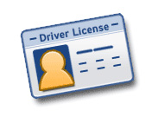You will need to have a valid driver’s license to drive a car in the U.S. A driver’s license is issued by the Missouri License Bureau Office. A driver’s license issued by one state is valid to use to drive in any of the states in the U.S.

To apply for a Missouri Driver’s License, you must take a written test and a driving test. For a copy of the Missouri Driver’s Manual you can go to [http://dor.mo.gov/drivers/dlguide](http://dor.mo.gov/drivers/dlguide/). You can also pick up a paper copy at the Springfield Contract Office. This manual will help you prepare for the test.

When you apply for a Missouri Driver’s License, you must have the following items:

* Passport with U.S. visa
* I-94 card
* Current I-20
* Letter proving current enrollment from the IPO
* Social Security Card or a letter from the Social Security Administration stating that you are not eligible for a Social Security Card

Please note that not all visas entitle the bearer to a Driver’s License. If in doubt about your visa qualifications, call the License Bureau at (573) 751-4600.

***Traveling Within the U.S.***

Immigration law requires that your I-94 be in your possession at all times as evidence of your legal entry and presence. However, it is highly recommended that when traveling anywhere within the U.S. that you carry all of your immigration documents with you. You may also wish to carry contact information for the IPO in case you experience any difficulties.

***Traveling Outside the U.S.***

If you are traveling to another country you may be required to have a visa to enter that country. To find information about visa and entry requirements you will need to consult the embassy or consulate for the country or countries that you may be traveling to or through. Here are helpful reminders when you plan to travel outside the U.S.:

* Check that your passport and visa are valid. If they are not, you will need to return to your home country to renew these documents before you may re-enter the United States.
* Verify that the information on your I-20 is correct.
* Bring your I-20 to the IPO at least one week before your date of departure for proper endorsement (two weeks prior to departure during busy travel times, such as the end of each semester and before Spring Break). *If you are an M-1 sponsored by another organization, you will need to obtain the travel authorization from the program officer at your sponsoring organization.
* While you are outside the U.S., take great care not to lose any of your documents. You will need them to re-enter the U.S.

Employment

*On Campus Employment*

International students with F-1 status may work on the OTC campus.

Before beginning employment at OTC, you must first obtain a Social Security number. To do so, submit your student identification, Visa documentation, offer of employment from the department hiring you, and a letter verifying your enrollment from the IPO office to the local Social Security Administration Office.

***Off-Campus Work***

Off-campus work may be approved in certain circumstances such as extreme financial hardship. Students must complete one year of successful academic performance to be eligible for off-campus employment. The Primary Designated School Officer (PDSO) must approve eligibility. Extreme financial hardship may include but is not limited to:

* Substantial fluctuations in the value of exchange rates or national currency
* Inordinate increase in tuition and/or living expenses
* Unexpected and substantial change in the financial conditions of the student's source of support, medical bills, or other expenses

Students are eligible to apply for off-campus employment authorization if they meet all of the following conditions:

* Must have been in F-1 status for one academic year
* Must be in good academic standing
* Employment opportunities on campus are unavailable or insufficient
* Can demonstrate that acceptance of employment will not interfere with their ability to carry a full course of study
* Students may work a total of twenty (20) hours per week when school is in session. All on and off-campus employment is counted toward this twenty-hour limit.

Employment authorization is granted in one-year intervals. The USCIS will only authorize renewals if the student is maintaining good academic standing. Employment authorization is automatically terminated if students fail to maintain status.

***Optical Practical Training (OPT)***

International students might wish to gain work experience while attending college or after finishing their program of study. OPT is authorized employment for F-1 international students permitting them to benefit from a work experience related to their field of study. Students should continuously be in full time status to be eligible for OPT. That is, they need to be enrolled on a full-time basis and have been in good status for at least one academic year. OPT allows students to work for 12 months. Students do not need to have a job to apply for OPT. They can apply for a job after their OPT application is approved. Students apply for OPT through the United States Citizenship and Immigration Services and they are responsible for paying application fees. F-1 International Students can engage in OPT before or after the completion of a degree program.

* **Pre-completion OPT:** Students who have already completed one academic year (at least one fall semester and one spring semester), can apply for the pre-completion OPT. Students who have not yet completed the full one academic year can also file for the pre-completion OPT provided that they are within 90 days of attaining a full academic year. Students cannot work more than 20 hours a week when doing a pre-completion OPT or before completing their program of study. However, they can work up to 40 hours while school is not in session (winter and summer breaks).
* **Standard post-completion OPT:** Students can apply for OPT up to two months before graduation or during the two months (grace period) following graduation. Students can engage in post-completion OPT upon the completion of the degree. USCIS must receive the I-765 and OPT I-20 no sooner than 90 days before the program end date and no later than 60 days after the program end date.

Pre-completion OPT and post-completion OPT must be related to the student's major area of study.

* **How does an international student apply for OPT?**

There are four steps to apply for OPT:  
1- The student makes a request for OPT to the PDSO.  
2- After eligibility is determined, the PDSO will update your SEVIS and recommend OPT.   
3- The PDSO will prepare an I-20 form with the OPT recommendation and the required signatures.   
4- The student files a form I-756, Application for Employment Authorization, including payment for the required fee, and a signed I-20 form showing that OPT has been recommended.

If OPT application is approved, students will receive an Employment Authorization Document, which allows them to start engaging in employment anywhere in the United States.

Please visit the official U.S. Department of Homeland Security to learn more about the eligibility requirements for an F-1 student OPT application <https://studyinthestates.dhs.gov/students/training-opportunities-in-the-united-states>

Academic Advising

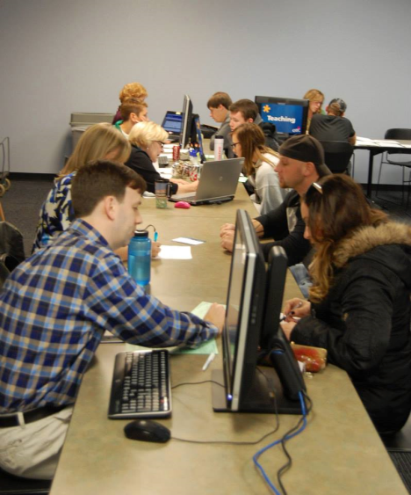Academic Advising assists OTC students in navigating through their academic program until successfully graduating or transferring. Students will meet with their academic advisor at least once a semester and their advisor will regularly be in contact to support and assist their students in achieving academic and personal success.

Your academic advisor will help ensure you complete your degree requirements and proactively connect you with the appropriate resources and information you need to be a successful student.

International Student Academic Advisor

Dr. Karim Moukrime is the academic advisor for all international students at OTC.

Financial Information

Paying Tuition at OTC

First year international students are required to pay for their first year of tuition and fees prior to admission. Transfer students are required to pay for their first semester of tuition and fees prior to admission. After the first year/semester of enrollment at OTC you will need to pay in full or set up a payment plan with the Cashier’s Office.

My Payment Plan

After registering for classes, you will need to make payment arrangements by the end of that same day in order to complete class registration. You will need to select payment arrangements every semester. More information is available at this web link: <https://services.otc.edu/finance/payment-plan/>

***QuickPay***

You may pay your tuition in full by making one immediate payment with a credit card, debit card, or e-check.

* Log in to MyOTC, select the “Access OTC” tab; Student Menu; Quick Pay

You can also authorize others to make payments on your behalf by using the “Authorized Payers” option.

***Enroll in My Payment Plan***

Ozarks Technical Community College utilizes the services of Nelnet payment plans to make the process easier for you. This is not a loan program. You have no debt, there are no interest or finance charges assessed, and there is no credit check for your payment plan.

* Log in to MyOTC, select the “Access OTC” tab; Student Mene; My Payment Plan
* Select Term; click on MyPay- Montly tab

For online help, email [cashhelp@otc.edu](mailto:cashhelp@otc.edu) or stop by the Cashier’s Office located on the second floor of the Information Commons building on the Springfield Campus.

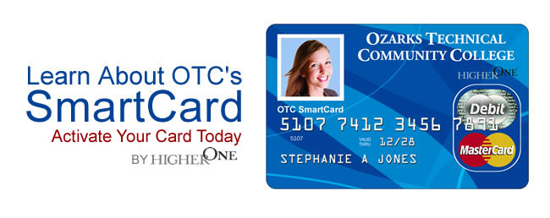OTC SmartCard

The OTC Smart Card is your official college identification (ID). All OTC students are required to have a SmartCard. It is your access card to get into the OTC Fitness Center and other campus resources. Some outside businesses will give you discounts when you show your SmartCard. You should carry your SmartCard at all times.

***How to get a card***

You may register for the SmartCard at the following locations:

* Springfield Campus: OTC Bookstore
* Branson Education Center: Main office
* Richwood Valley Campus: Student Services
* Lebanon Education Center: Main office
* Waynesville Education Center: Main office

***Refunds***

Ozarks Technical Community College has partnered with Higher One, a financial services company focused solely on higher education, to offer faster delivery of refunds to students. Higher One will help bring this new method for receiving refunds to OTC students via the [OTC SmartCard](https://otcsmartcard.higheroneaccount.com/).

To activate your SmartCard visit <https://otcsmartcard.higheroneaccount.com>

Campus Resources

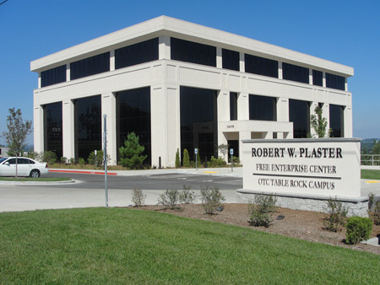Services & Offices

***OTC Bookstore***

Provides all required supplies and course materials for OTC classes. We also offer academic supplies, convenience items, official OTC apparel, gifts, and computer software and hardware; all available at a great value to students. The OTC Bookstore is located at the corner of Sherman Ave. and Brower St. on the Ozarks Technical Community College Springfield campus, just west of the information Commons.

Table Rock Campus

***Café 101***

Café 101, located on the OTC Springfield Campus, is OTC’s one-stop café shop. Offering a variety of foods for breakfast, lunch, and dinner, you are sure to find something you like. It is a great place to grab a bite while on campus.

***Starbucks Coffee***

Located on the main campus of OTC in Springfield is the Starbucks Coffee Shop. Starbucks serves hot and cold drinks, a variety of coffee drinks, full-leaf [teas](https://en.wikipedia.org/wiki/Tea), juices, [Frappuccino](https://en.wikipedia.org/wiki/Frappuccino) beverages, [pastries](https://en.wikipedia.org/wiki/Pastries), and snacks.

***Career Employment Services***

Career Employment Services assists students with their college major and/or career choice decisions through group and one-on-one career exploration appointments. Appointments with professional staff to discuss career options can be scheduled by calling 417-447-6964 or emailing [careeremp@otc.edu](mailto:careeremp@otc.edu).

***Carol Jones Writing Center***

Located in the Information Commons building, room 200 at the Springfield Campus, the Carol Jones Writing Center helps all people of all skill levels improve their writing skills. From brainstorming ideas to learning how to cite properly, they help with any step of the writing process.

***OTC Computer Labs***

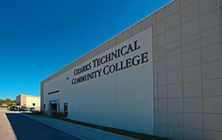OTC offers open computer labs where currently enrolled OTC students can do homework conduct research, print documents, and practice using software applications commonly found in the workplace. Labs will be opened on the first Monday of every semester, and a lab monitor is available to assist students with computer-related issues. Visit their website for more information <http://www.otc.edu/technology/computer-labs.php>.

***Cashier’s Office***

The Cashier’s Office is responsible for the billing and processing of tuition and fee payments, collection services on past due accounts, third party billings, and the disbursement of excess financial aid and all other refunds. The main Cashier’s Office is located on the Springfield Campus on the second floor of the Information Commons building, room 207.

Lebanon Center

***Counseling Services***

Counseling Services provides numerous supportive resources to assist members of the OTC community - high school students, college students, and OTC staff - with personal decisions. Counseling Services offers services on a regular basis at the Springfield Main Campus and the Richwood Valley Campus, and distance counseling services for the Branson, Lebanon, and Waynesville Education Centers.

***Disability Support Services***

The Disability Support Services Office offers support services to students with disabilities and faculty and staff who work with these students. The mission of Disability Support Services is to collaborate with faculty, staff, students and the community to encourage a college environment in which individuals are viewed on the basis of ability, not disability. For more information visit their office located on the Springfield campus in the Information Commons East room 116.

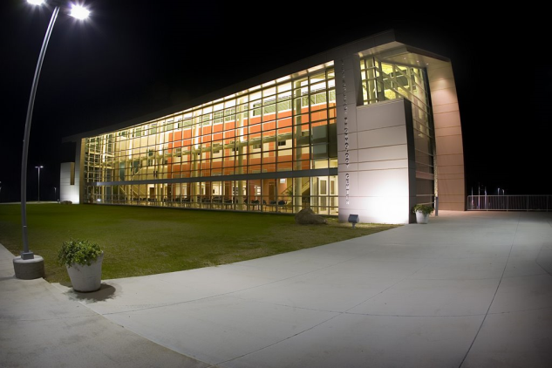***Fitness Center***

The OTC Fitness Center provides students with a safe and clean environment to exercise and workout where students can exercise on well-maintained equipment. We provide competent supervision designed to help students reach their health-related goals on the way to creating a healthy lifestyle. The Fitness Center is located in the Information Commons West building, room 115 at the Springfield Campus.

Richwood Valley Campus

***Library***

The OTC Library is home to thousands of resources to help you succeed. The library is a comfortable and convenient place to study and also has many online resources you can access from home. You may visit their website for hours of operation, location and resources. <http://www.otc.edu/currentstudents/library.php>.

***Speech Community Tutoring Center***

The Speech Communication Center is located within the Carol Jones Writing Center. It is dedicated to providing free student support through quality tutoring and mentoring in the areas of Public Speaking and the Communication discipline. The Speech Center will help students prepare and rehearse for any speech or group presentation.

***Student Services***

Student Services provides services and resolve issues in a timely manner, regarding registration, academics, counseling, records, testing, etc. For many students, Student Services is the point of contact for most if not all their college related questions. Visit their website for more information about their services [www.otc.edu/currentstudents/studentservices.php](http://www.otc.edu/currentstudents/studentservices.php). The International Program Office is located in the Student Services Office, Information Commons West building, room 109.

***Tutoring and Learning Center***

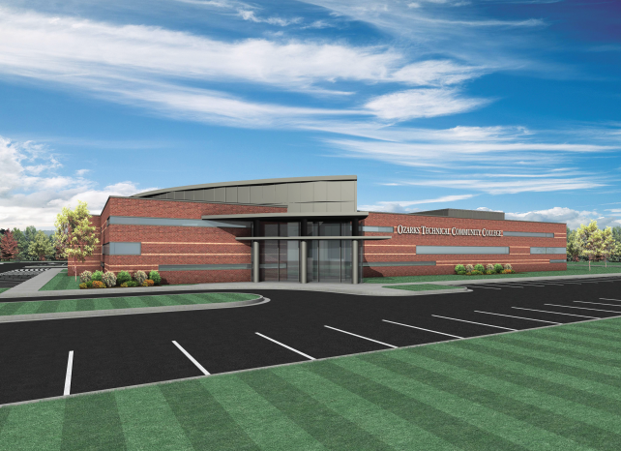The Tutoring and Learning Center (TLC) offers learning assistance in several precollege and college level courses. Students can receive assistance for such courses as Math, Computer Applications, Chemistry, A&P, and Study Skills. Math Tutoring and Computer Assistance (on Blackboard, MyOTC, and Microsoft Office) are available whenever the TLC is open. The TLC is located on Information Commons East building room 212 at the Springfield Campus. Contact the TLC office to make an appointment or to check on other tutoring services at other OTC campus/ centers.

Waynesville Center

***OTC Cares***

Being a college student presents a host of challenges.  Sometimes those challenges can result in a student needing help in difficult times.  ***OTC Cares*** is a set of resources that have been established to protect the health and safety of our community at OTC. Maintaining a safe environment allows students to focus on their education and get the most out of their time at the College.   To learn more about ***OTC Cares***, or to file a report of concern, please access the following link:  <http://students.otc.edu/bit/otc-cares>.

Living in Springfield

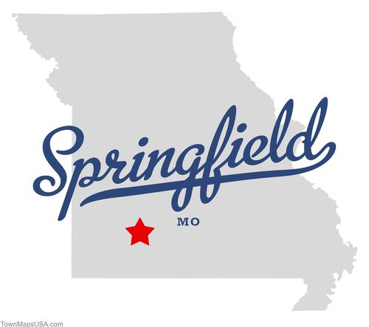Finding a Place to Live

It is your responsibility to make housing arrangements either before or after you arrive in Springfield. In order to avoid any unpleasant renting experience, you should carefully consider the overall condition of a residence and location when you look for a place to live. Be aware that rent differs depending on the conditions of the apartment or house you choose.

Ozarks Technical Community College has a website to help you to find off-campus housing, [http://housing.ozarkstech.org](http://housing.ozarkstech.org/).

Banking

Various banks are available in town; we encourage you to choose a bank that better your needs. The most commonly used account types are checking accounts and saving accounts. A few banking tips:

* Many banks offer free checking accounts.
* Visa and MasterCard check/debit cards are accepted in most stores and restaurants.
* Monitor your balance via online banking to avoid overdraft charges.
* Many banks will charge you a fee if you withdraw cash from an ATM belonging to another bank. Be cautious of ATM fees
* Some banks require that you keep a minimum balance in your account. If your account falls below this amount, you will be charged a fee.

Cell Phones

**Cell phones are available through a number of carriers in the area. Depending on the length of your term of study, avoid long-term contracts and look for carriers with pay-as-you-go options that let you choose a price point that will reflect your phone usage. There are also several pre-paid options in which you just purchase minutes as you need them.**

Shopping

**These are several large grocery stores, super-centers and a mall that are easily accessible by bus or within walking distance from OTC.**

***Grocery Stores Near OTC Campus***

|  |  |
| --- | --- |
| **Price Cutter**  **1260 E. St. Louis**  **Springfield, MO** |  |

***Specialty Grocery Shops in Springfield***

|  |  |
| --- | --- |
| **Binh Tay Oriental Food**  **1418 W. Sunshine**  **Springfield, MO** | **Nadia’s European Market**  **3023 E. Sunshine**  **Springfield, MO** |
| **Fine European Market**  **3630 S. Campbell Ave.**  **Springfield, MO** | **Seoul Oriental Market**  **3165 S. Campbell Ave.**  **Springfield, MO** |
| **Latino Market**  **1661 E. St. Louis Street**  **Springfield, MO** | **Tortilleria Perches**  **1601 W. Sunshine Suit M**  **Springfield, MO** |

*Other Shopping Centers*

|  |  |
| --- | --- |
| Battlefield Mall (shopping center)  2825 S Glenstone Ave  Springfield, MO | BassPro Shop Outdoor World (specialty store)  1935 S. Campbell Ave.  Springfield, MO |

You may also visit [www.springfieldmo.org](http://www.springfieldmo.org) to find events and activities in the Springfield area.

Parks & Recreation

**There are several city and state parks in or near Springfield. The city also has a wide network of trails for running or biking. For more information you may visit the Ozark Green Ways’ website at** <http://www.ozarkgreenways.org> **or to the Missouri State Parks website at** <http://mostateparks.com>**.**

Shipping & Postal Services

Domestic and International mail can be sent via the U.S. Postal Service. The main post office is located close to the OTC Springfield campus.

U.S. Postal Service Main Office

500 W. Chestnut Expressway

Springfield, MO 65801

Phone: 417.864.0117

Check with other carriers for rates and delivery times if you are mailing a package that is time-sensitive.

Emergency & Safety

Call 911, the nationwide emergency number anywhere in the U.S., to immediately contact police, fire department, or ambulance. OTC safety and security phone number is 417-447-6911.

Weather

The weather in Springfield is characterized by four distinct seasons. Winter officially starts in mid to late December; however you will notice a change in weather typically in November and the days will gradually get cooler. Cold weather usually last at least through February, but it can last much longer. The temperature during the winter months can range from the negative digits to 44°F.

Spring weather usually begins in March. Spring often has rain and some severe weather, such as thunderstorms and/or tornados. During the Spring, the average temperature can range from 60° F to 83°F in the later months.

Summer begins in late June. Temperatures during summer can range from 80° F to 100° and it can be extremely humid, especially in late Summer.

***Severe Weather***

Tornados sometimes occur in Missouri. A tornado is a vertical funnel of wind where winds can reach over 30mph, causing destructive damage. You should be aware of severe weather, especially in spring.

***Weather Alert***

Become familiar with the following weather terms used to describe potentially threatening or hazardous conditions:

*Tornado Watch*- is issued when weather conditions are favorable for the development of severe thunderstorms that are capable of producing tornadoes. In most cases, the potential exists for large hail and/or damaging winds in addition to tornadoes. Pay attention to the changing weather conditions. TV, radio, and the internet are good sources of information.

*Tornado Warning*- is an alert issued by weather service to warn that several thunderstorms with tornado have been spotted. Usually the tornado sirens will sound in the area, informing people that a tornado has been sighted or is forming nearby. You should take immediate safety precautions. This includes moving to an indoor shelter, stay away from windows and get to the lowest levels of a secure building. If you are in any the OTC’s facilities you will be directed by your instructor, safety and security personal or an OTC staff member to a safe location.

*Winter Storm*- is an event in which the varieties of precipitations such as snow, sleet, and/or ice may occur.

*Red Flag Warning*- Also known as a Fire Weather Warning is a forecast warning issued to inform an area that conditions are ideal for the rapid spread of wildfires.

***OTC Emergency Notification***

A messaging system is in place to alert students and staff of school emergencies and closings. Participation in this system is voluntary but highly recommended. Your cell phone must be able to accept text messages to receive mobile alerts. If your phone does not accept text messages, you can still receive the alerts via email. To sign up, go to MyOTC and click on the Emergency Notification tab. To complete the signup process, you must reply to the text message or email. OTC will not send spam or advertising through this system.

Hospitals/ Clinics

|  |  |
| --- | --- |
| **Cox South Hospital**  3801 S National Ave.  Springfield, MO 65807  417-269-6000  www.coxhealth.com | **Mercy Hospital**  1235 E Cherokee St.  Springfield, MO 65804  417-820-9590  www.mercy.net |
| **Cox North Hospital**  1423 N Jefferson Ave.  Springfield, MO 65802  417-269-2273  www.coxhealth.com | **Ozarks Community Hospital**  2828 N National Ave.  417-837-4000  www.ochonline.com |
| **Jordan Valley Community Health Center**  440 East Tampa St.  Springfield, MO 65806  417-831-0150  jordanvalley.org | **Jordan Valley Community Health Center –Dental**  618 N Benton Ave.  Springfield, MO 65806  417-831-0150  jordanvalley.org/services/dental |
| **Springfield-Greene County Health Department**  227 E Chestnut Expressway  Springfield, MO 65802  417-864-1658  health.springfieldmo.gov |  |

Campus Maps

Springfield Campus

International Program Office Located in ICW 109

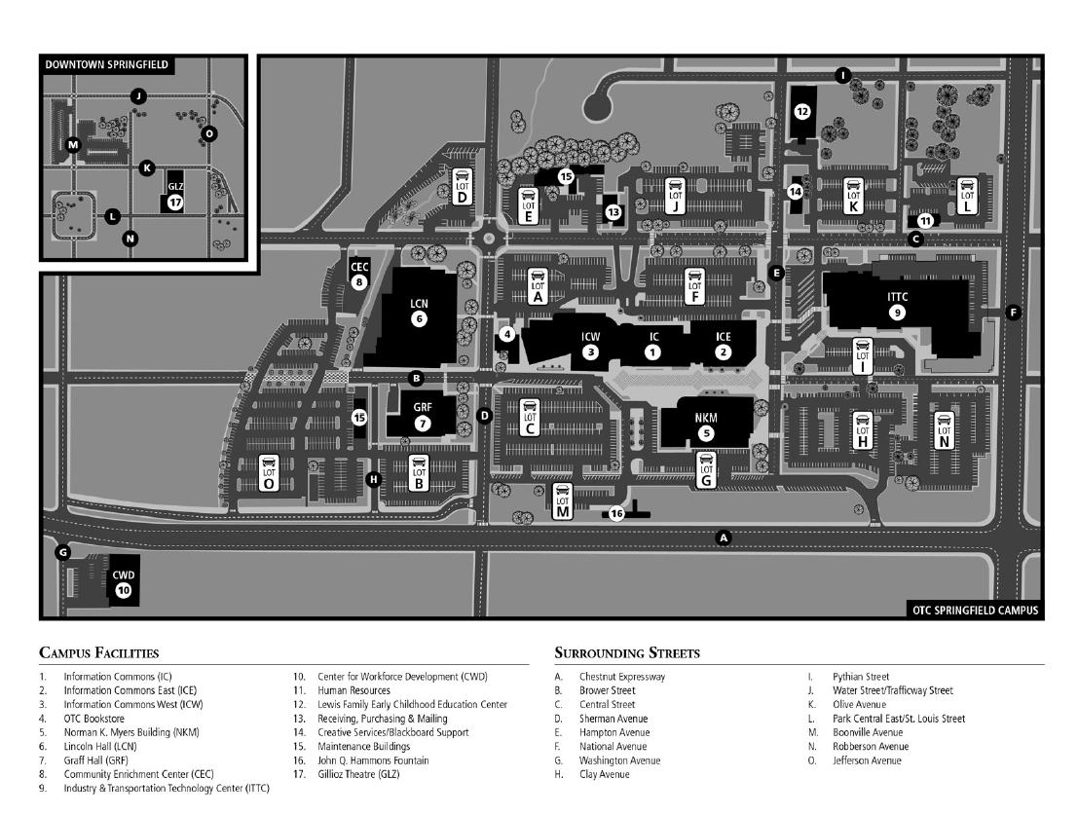

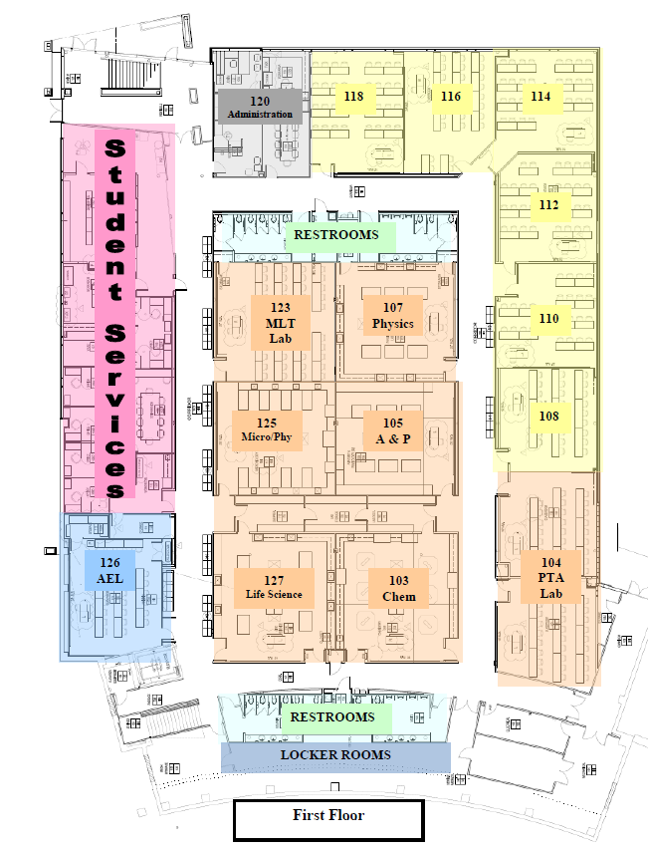Richwood Valley Campus

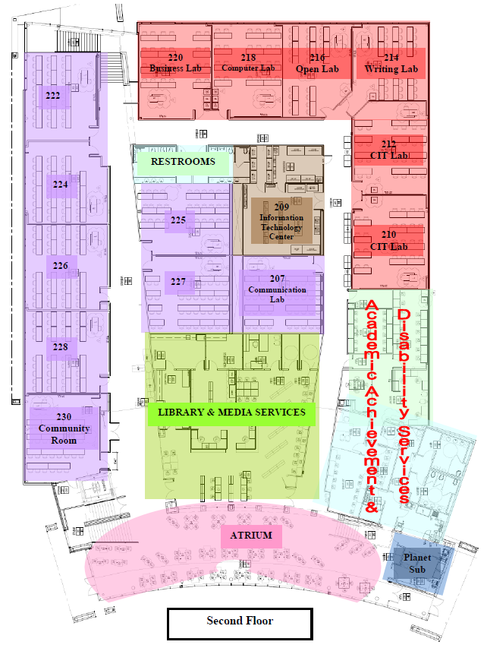

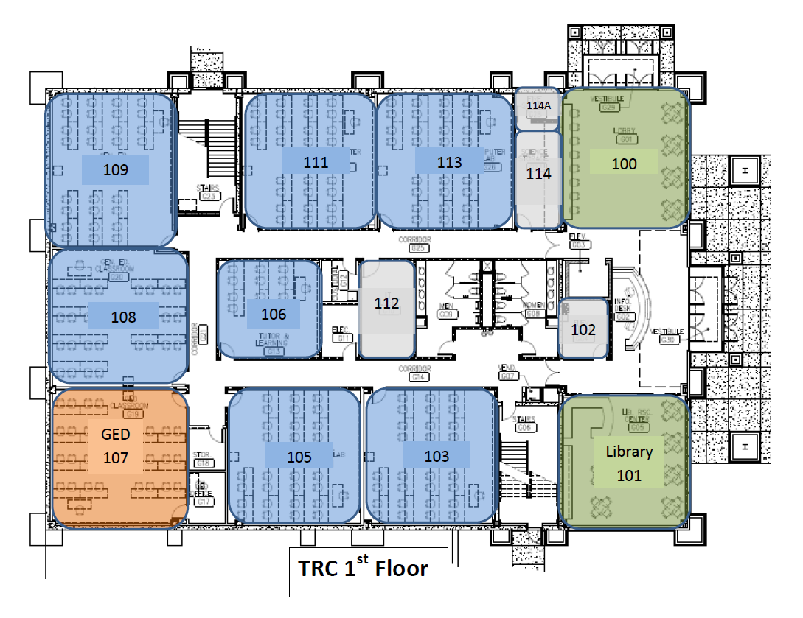Table Rock Campus Map

